Andrew Botsford
Andrew.botsford@inpex.co.jp
Andrew James Botsford (E5912101) B873 TMA02
August 2024
TMA02
Open University B873 Effective Strategic Management in Business and the Public Sector

Contents

Executive Summary 2
Task 1: Headquarters Level Strategy 3
How diversified is the business? 4
Options for developing and expanding the organisation 6
Organic Growth in Oil and Gas 6
Growth through Acquisitions in Net Zero Business 7
Task 2: Diversification 9
Developing Synergies 11
Industry Attractiveness Tests 12
References 16
Task 3: Participation in the Tutor group forum 17
Posts 17
Comments 21

Executive Summary
INPEX Corporation is an energy company with the vast majority (99%) of its revenues from oil and gas. It has employed dual growth strategy by focussing on both expansion of its existing business and separately outlining areas for business expansion, the five net zero businesses. Its corporate mission statements provide an overview of strategic direction but are ambiguous in detail.
It is recommended that organic growth is pursued in oil and gas, utilising existing capabilities and aiming to continue the strong revenue stream already experienced. Cashflows from oil and gas should be utilised to pursue growth through acquisition in new business areas allowing INPEX to improve its capabilities outside its traditional business, this is particularly important given the forecasted demand decline in oil and gas to 2050 and beyond.
Internationally INPEX is established in five geographic regions which are primarily linked to proximity to Japan, these also prioritise political and economic similarities with its home country. This is a sound approach that prevents over stretching of resources but might miss good opportunities outside these locations.
Diversification of the business is further recommended as spreading across multiple industries improves shielding against industry specific financial adversities, and there is potential to make better use of existing resources and capabilities. Careful attention should be paid to synergies and the pace at which diversification is enacted to prevent excessive growth and to ensure resources are developed synchronously.
This report addresses specific challenges in extracting synergies following company acquisitions that have been outlined by Goold and Campbell (2000), in general these can be addressed with careful planning and good communication. The attractiveness of growth industries has been assessed using Porter's (1987) three basic tests for diversification. Renewables and Hydrogen / Ammonia are the most promising as they offer growth market potential and align with existing capabilities of the organisation.

Task 1: Headquarters Level Strategy
INPEX Corporation is an energy company with the following corporate mission statement:
“We are committed to contributing to the creation of a brighter future for society through our efforts to develop, produce and deliver energy in a sustainable way.” (INPEX Corporation, 2024a).
This statement can be seen as an overarching view of the headquarters level strategy, providing general guidance to stakeholders including unit level managers in shaping their thoughts on who INPEX are and what businesses should be pursued. Within this statement the terms “brighter future” and “sustainable way” are open to interpretation and depend on the perspective and timeframe to be considered. For example, what does brighter mean? Perhaps more energy use for light but more likely to mean a prosperous and better future (for society) but there is implication that to achieve this the product (energy) will be needed. Sustainability is also open to question; in the near term (next few years) it might refer to continuing existing levels of oil and gas production but in the longer term (decades plus) it is more likely to mean energy production from renewables and replacing fossil fuels. Despite these ambiguities the statement concisely outlines the business activities in a broad sense and acknowledges the requirement to consider wider stakeholders.
In more detail the INPEX headquarters level strategy involves developing its oil and gas business and its net zero businesses separately (INPEX Corporation, 2024a). This is reminiscent of a dual transformation approach (Innosight, 2017) to potential industry disruption in that it separates the legacy business of oil and gas from growth businesses. The link between the two is shared capabilities that can be utilised in both pathways, for INPEX this includes culture, unique know how, and systems. In the oil and gas business, INPEX plan to fulfil responsibilities for the development and supply of energy by promoting a more resilient and cleaner business. In each of the 5 net zero businesses (hydrogen ammonia, CCUS, renewable energy, methanation, and forest conservation), INPEX aim to secure a position as a major player (this statement is also highly ambiguous).
The key decision makers responsible for developing headquarters level strategy are the President and CEO and the Executive Committee as indicated in Figure 1.
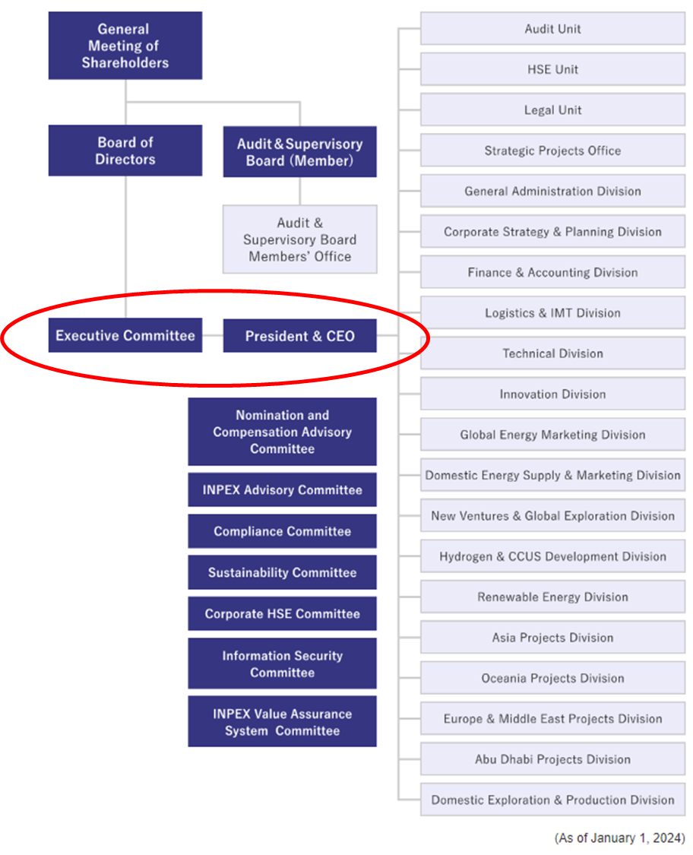
Figure 1: INPEX Corporation organisation chart with the position of headquarters level strategy decision makers indicated in a red circle. Adapted from INPEX Corporation (2024b).

How diversified is the business?
Rumelt (1974) defined the level of diversification of an organisation based on how it derives its revenues. This approach is purely financial and time specific, and unless considered over a period fails to appreciate the direction of movement both in historic and emerging business activities. Investments in new industries that are expected to achieve returns in future may not be reflected positively in this consideration, and new businesses for INPEX such as CCUS and forest conservation might never provide strong revenues in themselves but will be necessary to achieve sustainability in the core business by offsetting fossil fuel emissions. CCUS and forest conservation benefits will be wrapped up within the oil and gas business (vertically integrated) and success would be measured by contribution to the revenues recorded from those activities. An alternative narrative to the published INPEX strategy would not separate CCUS and forest conservation but would include them as product value additions to traditional oil and gas activities. However, as the need to invest in these activities is driven by external pressure (political will to decarbonise) a clear statement of intent, by defining the business, supports justification of capital allocation and potentially improves public perceptions.
Despite its inability to provide a complete insight, revenues monitored over a relevant period give good indication of the primary activities of a commercial organisation. Using the Rumelt (1974) definitions of diversification and employing revenue as a reference, the diversification of INPEX is low from an energy type (or product) perspective with 77% of revenue from oil production in 2022 and 74% in 2023 (Figure 2).
INPEX has moderate to high international diversification with 73% of revenue derived from overseas oil and gas in 2022, and 69% in 2023 (Figure 3). Overseas oil and gas in these data includes several projects each with a share below the 17-18% from the largest project which is based in Australia (Ichthys).
Figure 2: INPEX revenue diversification between oil, gas and non-hydrocarbon projects from 2022 and 2023 (INPEX Corporation, 2024).
Figure 3: INPEX revenue diversification between Oil and Gas Japan, Ichthys, other overseas, and other projects from 2022 and 2023 (INPEX Corporation, 2024).
INPEX is active in five core international regions (Figure 4). Within the CAGE framework of Ghemawat (2001) the selection of these regions seems to prioritise geographic preference with most regions lying close to Japan, although economic, and administrative and political factors play a key role in prioritising regions away from Asian time zones (Abu Dhabi and Europe). By refraining from business in areas such as the African continent due to perceived political hostilities and its remoteness, there is a possibility that profitable opportunities could be missed. Limiting geographic spread does enable concentration of resources in key areas, and significant changes to the current approach are not recommended.
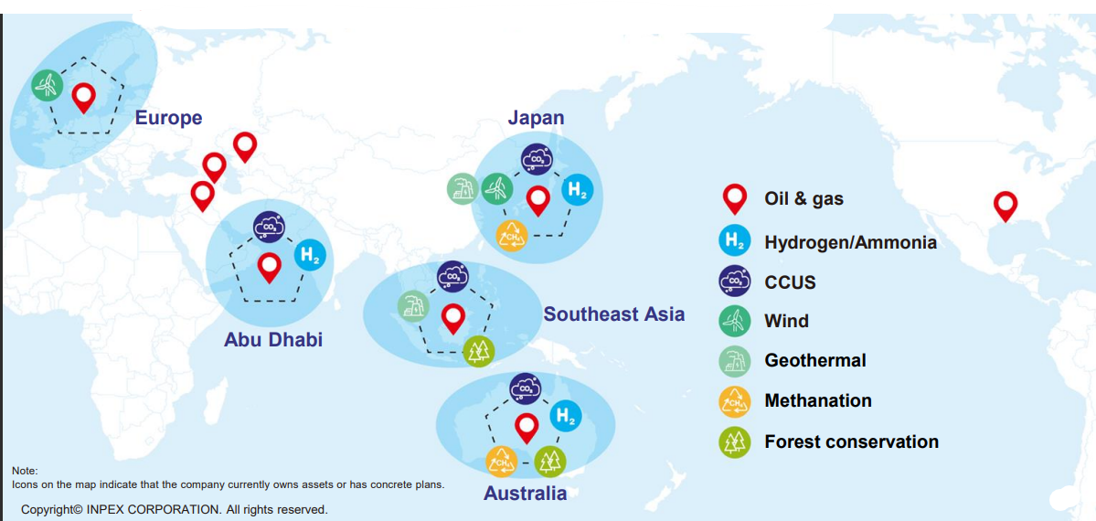
Figure 4: Locations of the main activities of INPEX Corporation (INPEX Corporation, 2022). The areas have been assigned into five core regions.

Options for developing and expanding the organisation
As announced by INPEX Corporation (2022), estimated cash allocation for growth from 2022-2030 is ¥3.8–4.4 trillion to oil and gas and ¥0.7–1 trillion to the 5 net zero businesses (ie 15-18% investment in net zero, or growth, business). It is recommended that this split in resource allocation is reviewed regularly with reaction to external market signals.
The available options to achieve growth include focussing on internal expansion through organic development, or through external growth methods via mergers, acquisitions, and alliances. An alternative option to growth would be to reduce the size of the organisation by selling off assets and returning cash to shareholders. It is proposed here that organic growth should be maintained in oil and gas whilst acquisitions should be pursued to achieve growth in net zero business areas.

Organic Growth in Oil and Gas
INPEX has a worldwide footprint with 3,531 contracted employees (INPEX Corporation, 2024a) with the knowledge and capabilities required to operate existing facilities and to conduct organisation tasks (mainly in oil and gas). INPEX can use its existing technical capabilities to obtain and develop new opportunities in its core business which negates the need to spend time and resources looking for new partners, and the INPEX culture can persist without having to spend time and resources on integration. Organic growth tends to be slow but there is currently no need to rush into something given relatively stable revenues from 2022 and 2023, moving too fast might lead to resource stretching and a reduction in operational performance.
A major challenge with only following this approach is that there is a relatively narrow route for expansion in a single industry and many employees are and will be highly trained in skills relevant to oil and gas which may not easily contribute to growth industries. A significant industry downturn could leave the organisation over resourced in these capacities and unable to sell down at an attractive price. Regular external market data should be gathered and if significant downward trends are observed a combination of asset sales while prices are still attractive or reallocation of resources to growth businesses should be applied.

Growth through Acquisitions in Net Zero Business
Acquisition of new firms is recommended primarily to extend the scope of the INPEX business and to acquire new resources and capabilities reducing future reliance on the oil and gas industry for revenue generation. Aggressive acquisition of early movers might also provide the benefit of reducing the number of competitors, but this is a high-risk approach in emerging industries, so it is important to strike the right balance. Regular market monitoring should support this approach.
It might be possible to expand into new markets by merging or forming alliances with other companies, however it is likely to take a very special circumstance to find a business offering completely complementary activities therefore some value destruction is likely to occur due to duplication of tasks. It is also highly likely that any merger will favour one side and will be perceived as an acquisition of one by the other which can create cultural challenges. It is therefore recommended that acquisition is used to scale up new business, emphasising and utilising the corporate identity and organisation if INPEX. This approach can achieve results quickly and purchases should retain some value and be saleable if they are subsequently seen as inadequate.
Acquisitions in new business areas will allow INPEX to improve its capabilities outside its traditional business. Targets within the net zero classification generally show strategic fit, so several options are available. Acquisitions should ideally be undervalued firms with poor leadership where INPEX direction can help extract more value. It will also be important to consider management practice and organisational culture in any target firm to ensure future business activities can be carried out effectively.
Pricing might present a challenge in some growth markets, but careful monitoring of industry trends should ensure market price (or less) is achieved. A specific area where acquisitions should be targeted is in renewable power production through acquisition of wind farm and solar assets, as these industries provide clear synergies with our existing business and employees can be reallocated in response to external environment changes.

Task 2: Diversification
The statistics in Figure 2 and Figure 3 show that INPEX has very low diversification beyond its current core business of oil and gas delivery. Whilst this business is likely to be viable for many years due to its existing scale, outlook forecasts are starting to predict a decline in demand in coming years, especially in advanced economies (Figure 5). As a high proportion of INPEX projects are in advanced economies (Figure 4) there is likely to be strong need to diversify from oil and gas over the timeframes considered in Figure 5 (up to 2050). Diversification will enable INPEX to remain relevant and add value by facilitating growth of new industries supporting societies’ needs. On the other hand, financial returns might be lower than those enjoyed by traditional oil and gas activities.
Within emerging industries financial viability is less proven and there is less certainty in future market outlook due to a lack of historical data. Whilst INPEX could focus all its resources on optimising oil and gas production, diversification is endorsed for several reasons. Spreading across multiple industries improves shielding against industry specific financial adversities, there is potential to make better use of existing resources and capabilities, and excess cash flows can be utilised in future proofing the organisation. Diversification can help expose employees to new industries and activities, developing skills and capabilities.
Careful attention should be paid to synergies and the pace at which diversification is enacted to prevent excessive growth and to ensure resources are developed synchronously. The example of Merrill Lynch adding mortgages to their portfolio in around 2005 without having clear strategy (ie considering why they are adding them) lead to having to file for bankruptcy in 2008 as they were unable to adapt to change brought on by the financial crisis, according to Morgenson (2008).
Diversification into related industries is favoured as it can take advantage of economies of scope by improving output from existing resources (lowering unitary costs). An example of this for INPEX is applying offshore engineering resource from the oil and gas business into offshore wind development. Unrelated product diversification is less able to take advantage of economies of scope but can still utilise excess cashflow for growth, and less integration will be required if businesses continue to be run separately. An example where this is relevant to INPEX targets is in forest conservation.

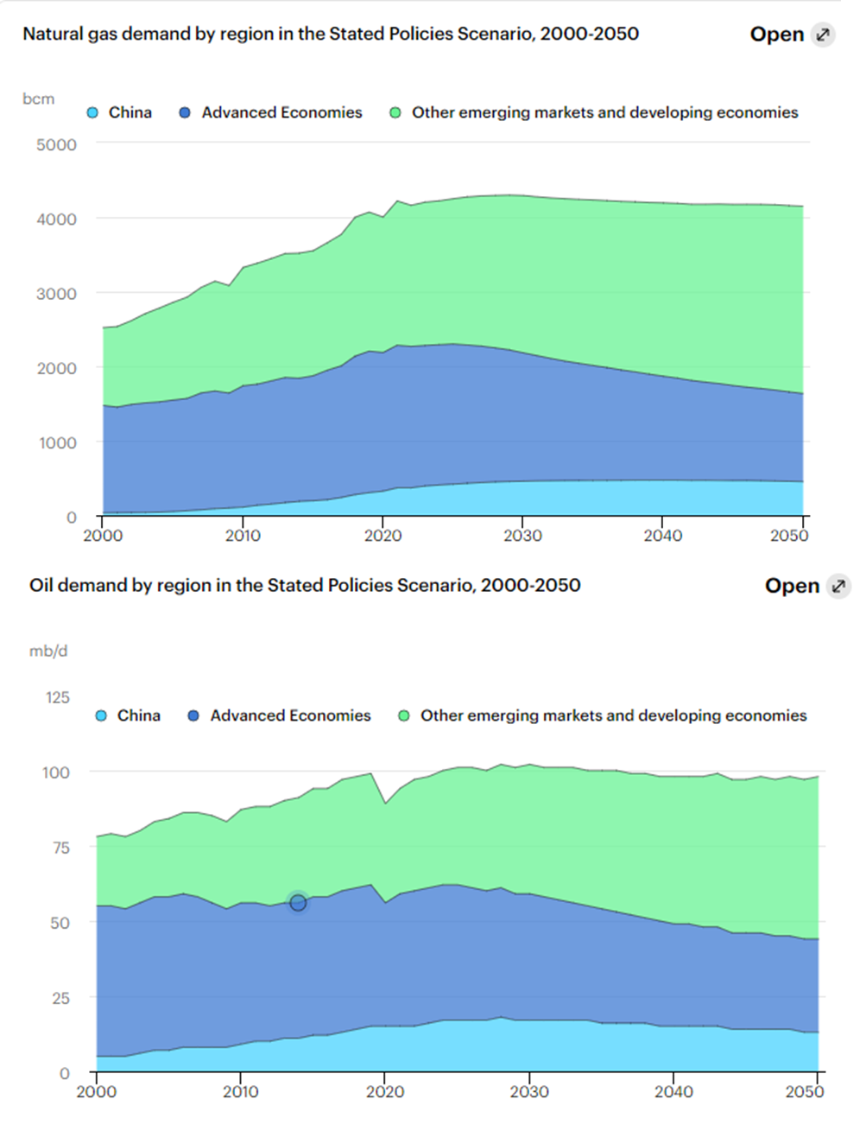
Figure 5: Predicted outlook for global gas and oil demand to 2050 in the IEA stated policies scenario (IEA, 2023).
The growth businesses being targeted by INPEX (INPEX Corporation, 2022) all have some level of integration with existing business as an energy supplier. Renewable energy represents horizontal integration in that it results in a position of being able to provide energy as a product from more than one source. The development of methanation and hydrogen businesses are methods of forward vertical integration in that they involve development of an energy product and moving closer to customers. CCUS and forest conservation can be considered vertical backward integration as they add value to a product, in effect its supply chain, by offering decarbonised credentials on oil and gas products.
Staying in related industries equips INPEX better when it comes to make-or-buy decisions. Many tasks in relation to oil and gas project development are outsourced including marine data acquisition and design. This type of outsourcing and existing methods of communication with third parties can be utilised in the renewables industry. In totally new industries it might be hard to develop knowledge of reliable suppliers or to understand the difficulty in carrying out certain tasks. For example, INPEX has no knowledge of food distribution and how to get products into supermarkets so would need to use resources to understand how to do this and there is no competitive advantage.

Developing Synergies
There will be several challenges in realising synergies between oil and gas activity and newly acquired business units such as those in renewables. Table 1 outlines and addresses those recognised by Goold and Campbell (2000).
Challenge | Recommended Approach
Widespread adoption of corporate strategy | Clear, straightforward, and inclusive corporate vision. Regular communication with subsidiary leaders to support strategy development and promote inclusivity.
Disagreements between subsidiaries hindering collaboration | Provide clear definitions of roles and responsibilities, minimising overlap.
Mistrust resulting in problems with information sharing | Take time to build trust supported by team building activities. Clear explanations on purpose can support understanding and facilitate building of trust.
Misaligned incentives preventing focus on corporate goals | Incentives should be aligned to corporate and subsidiary results, but the context of the subsidiary and appropriate measurement of its impact must be applied. Offshore wind, whilst delivering lower revenues than oil and gas, is providing diversification. Its impact could be measured on how it transfers skills around the organisation rather than how its revenue from individual projects evolves.  Development and reinforcement of corporate values that promote honesty and integrity can foster a culture of inclusivity and prevent siloed thinking.
Excessive pressure on subsidiaries reducing their capacity to seek synergies | Review operational procedures and ensure appropriate levels of scrutiny are placed on the subsidiary.  Whilst synergy development should be imposed to an extent, some level of natural process should be allowed to take place.
Lack of pressure on subsidiaries to seek synergies
Poor perceptions of corporate staff resulting in increased resistance from subsidiaries | Open and honest approach from corporate staff, explaining reasons for decisions and clearly communicating the end objective aimed at the best outcome for the organisation.  Be open to criticism and develop ideas in collaboration with subsidiaries.
Table 1: Challenges in extracting synergies from newly acquired subsiaries and some recommendations for addressing them (adpated from Goold and Campbell, 2000).

Industry Attractiveness Tests
Target businesses for INPEX should pass Porter’s (1987) essential three tests for diversification: 1. Whether the new industry is attractive now or in future (in terms of market size), 2. Whether a targeted acquisition can benefit from management by INPEX or INPEX can benefit from including it, and 3. Whether the price to be paid can be reasonably returned by future revenues directly or indirectly resulting from the transactions. Table 2 considers these three questions in relation to the 5 net zero businesses INPEX has identified for growth.
In summary, the diversification into new products (energy sources) as proposed by the INPEX strategy (INPEX Corporation, 2022) is strongly endorsed. An analysis of the five growth industries proposed using Porter’s (1987) tests suggest Renewables and Hydrogen / Ammonia are the most promising as they offer growth market potential and align with existing capabilities of the organisation. Diversification into new industries will create challenges in merging cultures, but these can be addressed with careful planning and good communication.
New Business | Attractiveness of market  1 = Smaller Market Potential  5 = Larger Market Potential | Better-off  1= Lower Synergy  5 = Higher Synergy | Cost-of-entry  1 = Higher  5 = Lower
Hydrogen / Ammonia  (10/15) | The global outlook for hydrogen as a future energy carrier suggests this is a growth industry, although challenges remain in predicting the scale and size of industrial growth. (4/5) | INPEX has transferable experience from managing and trading hydrocarbon energy carriers providing potential benefits from economies of scope. (3/5) | Early entry into the industry will enable organic growth and be cheaper. Quicker advancement through M&A or infrastructure investment is more expensive but could provide an advantage. Market growth projections suggest commercial viability in the longer term. (3/5)
CCUS  (8/15) | Political pressure on carbon dioxide emissions means several countries have included CCUS in their carbon budgets, but funding mechanisms to support the business rely strongly on political support. (2/5) | INPEX has experience managing subsurface hydrocarbon reservoirs for extraction purposes so is well placed to repurpose these capabilities to inject and safely store carbon dioxide. (5/5) | Site screening is a costly process so should be prioritised where there is existing market knowledge. This is likely to be a low margin business so much less attractive than traditional fossil fuel extraction. (1/5)
Renewable Energy  (11/15) | Wind and solar and other renewables are expanding dramatically and are likely to be key energy providers in future. The industry is attractive due to its sustainability and relatively low environmental impact credentials. (5/5) | INPEX has experience distributing energy to customers, but it may be stretched to achieve expert capabilities in wind and solar development. (2/5) | Entry costs of some renewable businesses such as solar and offshore wind have reduced, but longer-term returns are smaller than traditional fossil fuel activities. (4/5)
Methanation  (9/15) | Methanation offers a pathway for carbon dioxide usage, reducing carbon emissions and producing an energy carrier in synergy with growth in renewable energy supply. (3/5) | INPEX has carbon dioxide feedstock from many operations and is developing customer relationships. Experience handling and delivering fuels can enable this venture to be successful. (4/5) | Technology costs may be high but low risk organic growth from an early stage is preferred, but some risk might be necessary to gain first mover advantage. (2/5)
Forest Conservation  (7/15) | Supporting forests helps create carbon sinks to counter act harmful fossil fuel emissions associated with other business activities. (1/5) | INPEX has no specific expertise in this area. (1/5) | Whilst the entry costs are relatively low the impact of this business is also unlikely to make a material impact on revenues, but it can be good from a public relations standpoint. (5/5)
Table 2: Consideration of Porter's (1987) three basic tests for diversification industry targets identified by INPEX Corporation (2022). For comparison, each industry has been ranked in each test and the scores summed to give a comparable attractiveness score for each industry.

References
Bower, J.L. and Gilbert, C.G. (2007) “How managers’ everyday decisions create or destroy your company’s strategy.” Harvard Business Review, Vol. 85, No. 2, pp. 72–79.
Ghemawat, P. (2001) ‘Distance still matters’, Harvard Business Review, (79)8, pp. 1–12.
Goold, M. and Campbell, A. (2000) ‘Taking stock of synergy: a framework for assessing linkages between businesses’, Long Range Planning, 33(1), pp. 72–96.
IEA (2023) World Energy Outlook 2023. Available at: https://www.iea.org/reports/world-energy-outlook-2023 (Accessed: 16/7/2024)
Innosight (2017) Dual Transformation Explainer Video. Available at: https://www.youtube.com/watch?v=FSH6HFu5ufM (Accessed: 15/7/2024)
INPEX Corporation (2024a) INPEX Corporation Integrated Report 2023. Available from: https://www.inpex.co.jp/english/ir/library/integrated_report/ (Accessed: 12/7/2024)
INPEX Corporation (2024b) INPEX Corporation Organizational Chart. Available from: https://www.inpex.co.jp/english/company/organization.html (Accessed: 16/7/2024)
INPEX Corporation (2022) INPEX Vision @2022. Available from: https://www.inpex.co.jp/english/company/pdf/inpex_vision_2022.pdf (Accessed: 15/7/2024)
Johnson, G., Whittington, R. and Scholes, K. (2011) Exploring strategy – Text and cases. Essex: Pearson Education Limited.
Miles, R.E. (1978) “The Origin and Meaning of Miles' Law”. Public Administration Review Vol. 38, No. 5 (Sep. - Oct., 1978), pp. 399-403
Morgenson, G. (2008) ‘How the thundering herd faltered and fell’, The New York Times, 8 November. Available at: www.nytimes.com/2008/11/09/business/09magic.html (Accessed: 17/7/2024).
Porter, M.E. (1987) ‘From competitive advantages to corporate strategy’, Harvard Business Review, 65(3), pp. 43–59.
Rumelt, R. (1974) “Strategy, structure and economic performance.” Boston: Division of Research, Harvard Business School.

Task 3: Participation in the Tutor group forum

Posts
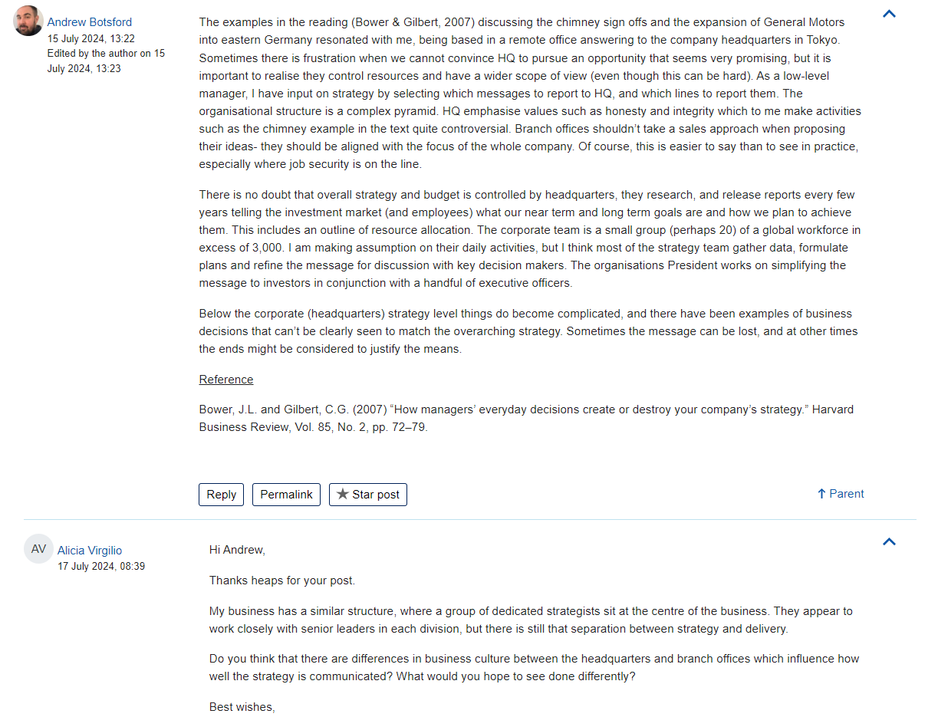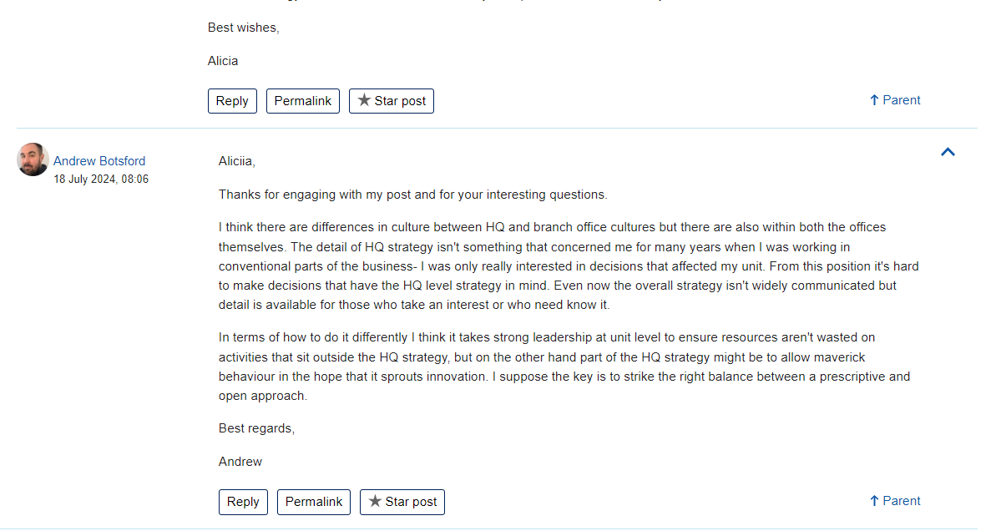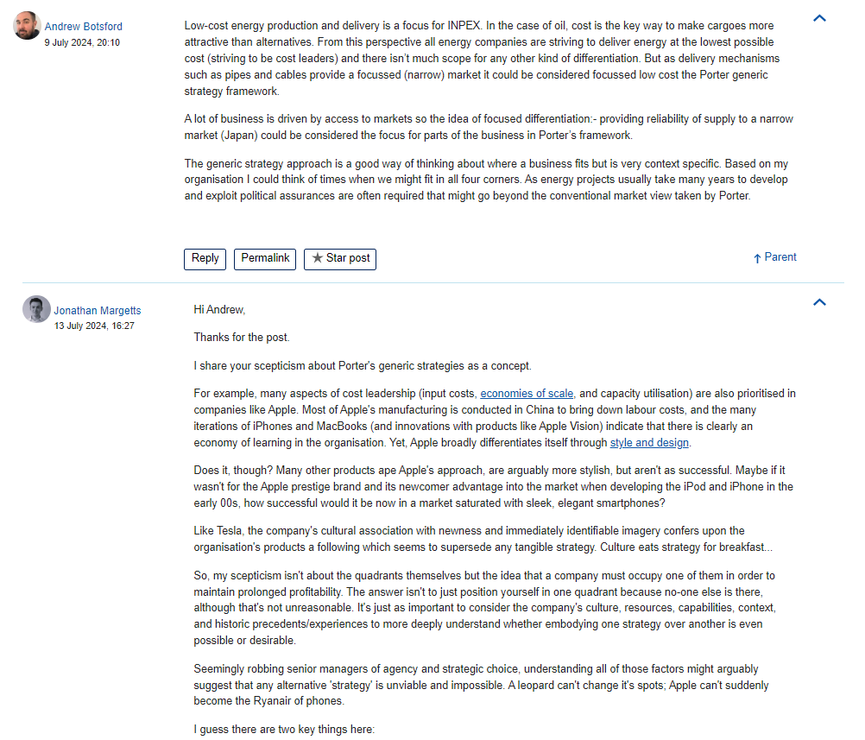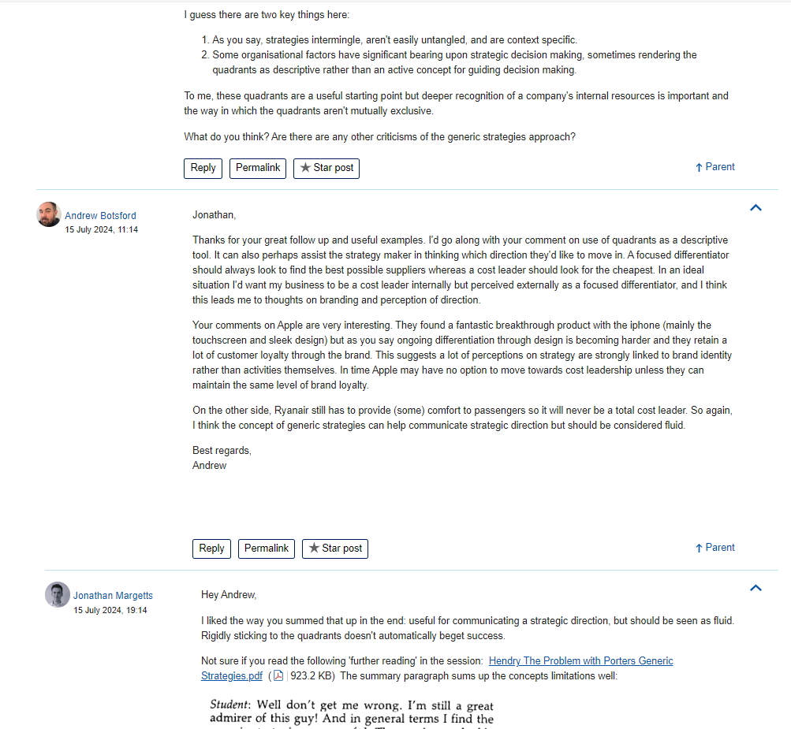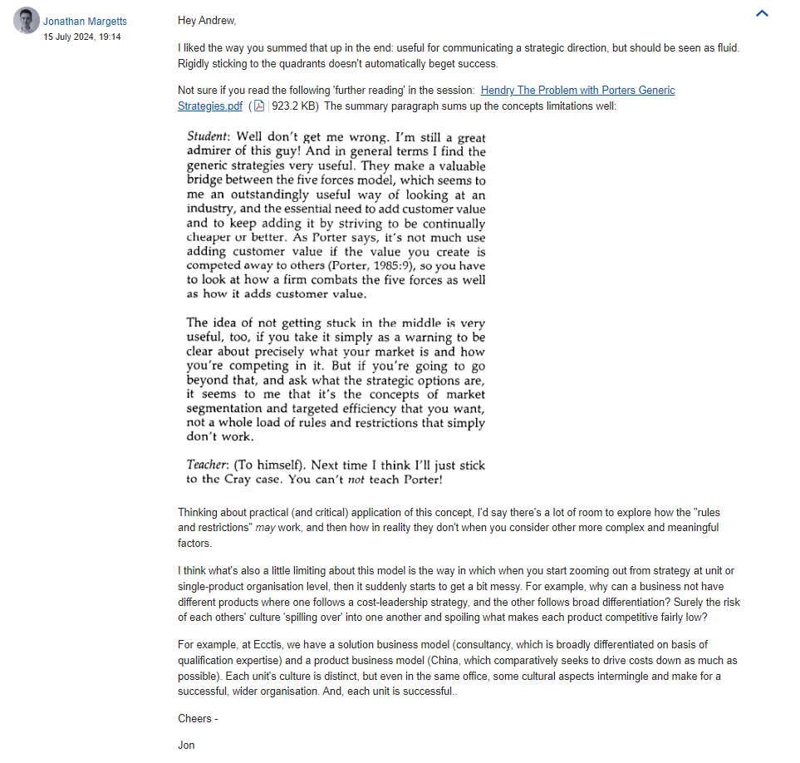

Comments